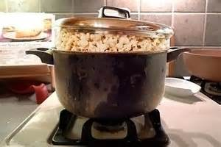
Popping Popcorn on the Stove
Direction on how to make popcorn on the stove:
Put oil and popcorn kernels into a pot with a lid. Cook on medium heat so that you do not burn the popcorn. After a little while you should hear the first pop. Continue cooking until the popping slows or stops.

Extended Response Question
A. Describe the energy transfers that take place in this situation from start to end.
Be sure to include:
- the energy that is supplied to start the reaction,
- what energy transfers occur?
- where does all the energy end up?

B. Construct a Sankey Diagram to show the energy transfer.

